< FOOD MANAGEMENT SYSTEM

**Use-Case Specification: Adding New Product**

Version <1.0>

Revision History

|  |  |  |  |
| --- | --- | --- | --- |
| **Date** | **Version** | **Description** | **Author** |
| <7/12/2020> | <1.0> | <details> | <Nguyen Thu Trang> |

Table of Contents

1. Use-Case Name 4

1.1 Brief Description 4

2. Flow of Events 4

2.1 Basic flow 4

2.2 Alternative flow 4

2.2.1 <First Alternative flow> 4

2.2.1 <Second Alternative flow> 4

3. Special Requirement 4

3.1 <First Special Requirement> 4

4. Preconditions 4

4.1 <Precondition One> 4

5. Posstcondition 4

5.1 <Postcondition One> 4

6. Extension Points 4

6.1 < Name of Extension Points> 5

**Use-Case Specification: Adding New Product**

1. **Adding New Product**

**1.1 Brief Description**

This use case defines the steps of adding a new product to restaurant it in the database system. Administrator can easily add a new product in the database.

1.2 Actor

Administrator.

**2. Flow of Events**

**2.1 Basic Flow**

The system administrator selects to add a new product and enters all information of this product to restaurant in the database system. The administrator sets the database management parameter that holds product information that has just added. The system displays the new product data value and logs the change.

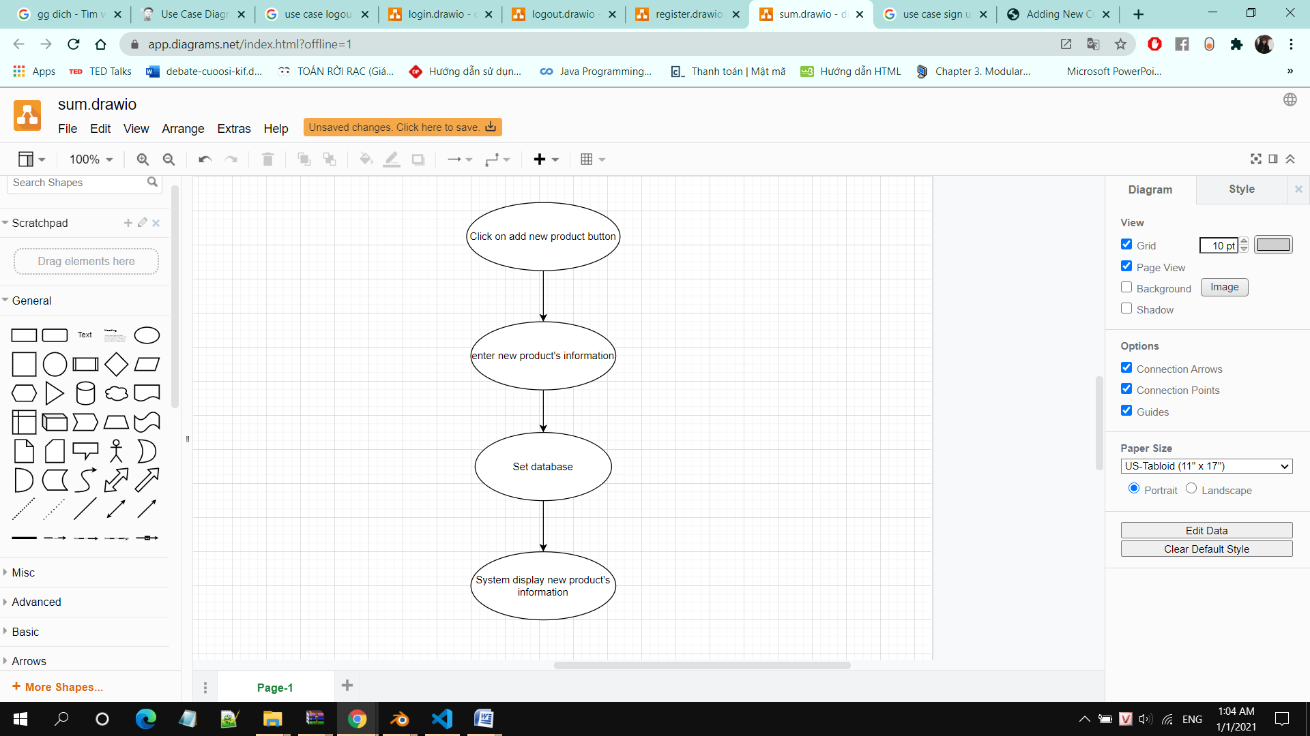

1. **Special Requirements**

Administrator has basic knowledge of manipulating the database.

**4. Preconditions**

The added product had not existed in the database before.

**5. Post conditions**

Administrator checks the database and the website to ensure that the new product is added successfully.

**6. Extension Points**

No extension points.